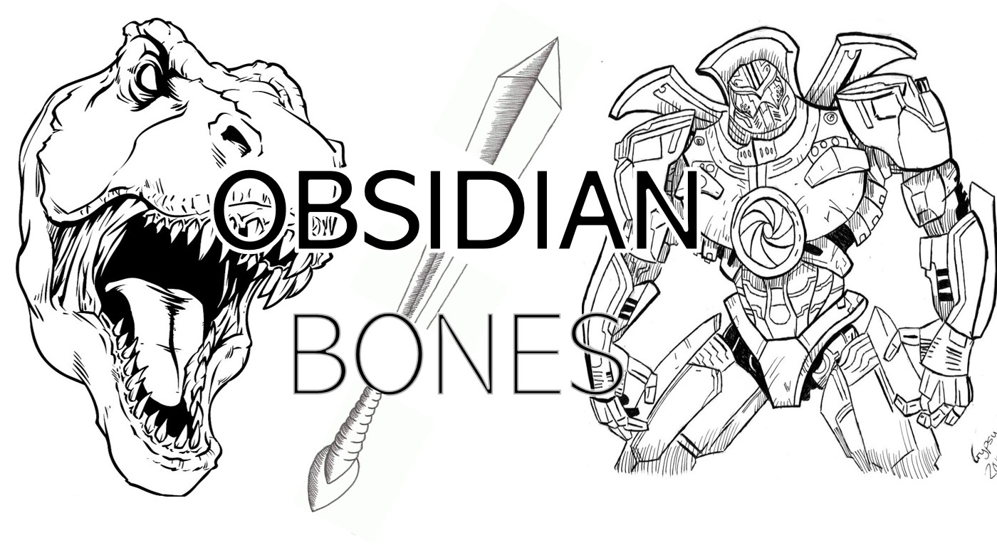

Game Pitch Document

Team 5

<Team Name>

Obsidian Bones

09/22/2020

Version 1.0

**Table of Contents**

Executive Summary 3

High Concept 3

Core Gameplay: Mechanics and Dynamics 3

Core Gameplay Aesthetic 3

Look and Feel Aesthetic 4

Genre, Platform, and ESRB 6

Audience and Targeted Customers 6

Game Differentiators/Unique Selling Points 6

# Executive Summary

## High Concept

Obsidian Bones is an action platformer where you have to time travel through different eras to save the world. Slash and blast through each stage, picking up enemies’ loot and upgrading your skills along the way. Face foes from various time periods and beat each stage’s boss to advance.

## Core Gameplay: Mechanics and Dynamics

Fight through each era to save the planet and humanity from their most perilous foes. Use your sword and daggers to defeat enemies on your path before confronting their respective boss. Upgrade those weapons after each era to evolve and become stronger.

The game uses the following mechanics: As the hero you can move left or right, jump, shield, pick up items, and use your skills to kill enemies. Your first skill has no cooldown and consists in swinging/stabbing with your sword (M1). Your other skill has a 2 seconds cooldown and consists in throwing your daggers for long-range damage (M2). Killing enemies drops items that you can pick up to either regenerate your life as your fighting or later use to improve your health and skills. You have a better chance of defeating the final boss with more items which help you get those improvements. Jumping is used to dodge enemy attacks and to move more smoothly through the levels. Another method to defend yourself against enemies is to use shielding to parry the attacks endured.

## Core Gameplay Aesthetic

< What sort of feelings is the game trying to evoke in the player? Use the gameplay aesthetics as guides but drill down to be make the general category specific for your game, e.g. enactment challenge occurs when players are jumping between platforms, which requires a high degree of eye-hand coordination.>

## Look and Feel Aesthetic

The game is really trying to immerse the hero in each era to give the player a sense of progression and time traveling as he/she defeats the bosses and progresses through the eras. By having appropriate and characteristic backgrounds (and enemies) for each era (Pre-historic, middle-ages/Renaissance, WWII, Current modern era, Future/Robot revolution) the player will be able to feel as if he/she is revisiting the past (looking back at history) for the first 3 levels, but will also get to experience a fantasy in the last level by being plunged in a futuristic world. An important detail to not neglect is that the hero will not change weapons nor clothes to fully give the player a time traveler perspective.

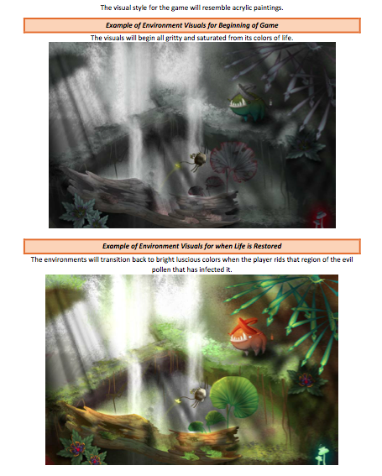

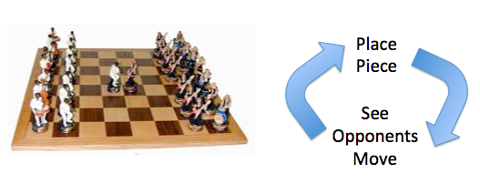

Figure 1: Medieval War – Brightly Colored Armies

<Use the following to help with the words…

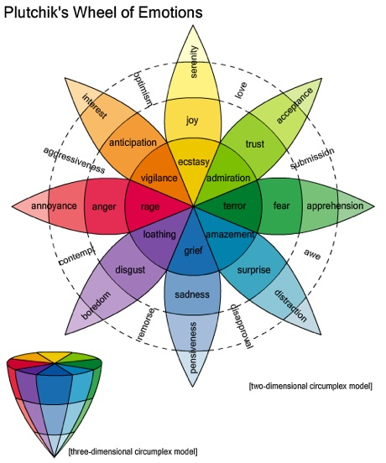



### Genre, Platform, and ESRB

<State the platforms that the game will be deployed and expected ESRB and why (See <https://en.wikipedia.org/wiki/Entertainment_Software_Rating_Board>). Platform is browser based.>

### Audience and Targeted Customers

<Briefly describe the audience and why you think this game will be popular with the audience. Make a player persona (<https://en.wikipedia.org/wiki/Persona_(user_experience>) and <https://medium.com/@fernandocomet/the-player-persona-template-d171e3e0c05d>). Include similar games that the audience may have played previously and enjoyed.>

## Game Differentiators/Unique Selling Points

* <List 1-5 features or elements that makes your game different from those played before.>

Signatures verifying agreement: